RESTURENT BILLING

MANAGEMENT SYSTEM

DESIGNED AND DEVELOPED BY

SADHIK SHAIK

INDEX

|  |  |  |  |
| --- | --- | --- | --- |
| S.N0 | | TOPIC | |
| 1 | Abstract | |
| 2 | Introduction | |
| 3 | Training | |
| 4 | Challenges Faced | |
| 5 | About Project | |
| 6 | Photos & Video Links | |

# 1.ABSTRACT

This is a project on that which I created on java programing ,that I have learned during the our academic ,during the 2nd year on 2nd semster .

The project is about the website on the restaurant management system where is a basic program used in restaurant. The main aim is to be perform the process of ordering and billing of a “Restaurant”. The languages by using java, SQL. This is the profession of managing a restaurant billing. It includes the major function of planning, organizing efficiently and effectively plan menus at profitable prices. This system will help to manage the restaurant billing system systematically. we will provide software that can be used by the cashier. This system has the capability to give the receipt to the customers. To reduce the time, energy, and resources that was being consumed when performing a billing for the customer.

In Offline sessions our mentors gave training on the given topics:

* Java-OOP’s Concepts
* Exception Handling and Multi-Threading
* GUL tools ( Swing ,AWT)
* JDBC connectivity .
* MySQL Workbench .

There is a badge to be completed for completion of internship that is: Hacker Rank Java Programming. At the end of the internship, we have been divided into groups and each group has been assigned with Java projects in real-time applications scenarios.

**Project Abstract:**

The project “Restaurant Billing System” is a basic program used in restaurant. The main aim is to be perform the process of ordering and billing of a “Restaurant”. The languages by using java, SQL.This is the profession of managing a restaurant billing. It includes the major function of planning, organizing efficiently and effectively plan menus at profitable prices. This system will help to manage the restaurant billing system systematically. we will provide software that can be used by the cashier. This system has the capability to give the receipt to the customers. To reduce the time, energy, and resources that was being consumed when performing a billing for the customer.

# 2. INTRODUCTION

During this project in Java, I developed into the foundational aspects of programming, with a primary focus on Object-Oriented Programming (OOP), Exception Handling, GUI Tools (Swing And AWT) and JDBC Connectivity. This immersive experience has equipped me with the essential skills and knowledge needed to excel in Java development.

I gained a deep understanding of OOP principles, which form the backbone of Java development. This involved creating and managing classes, objects, and inheritance, as well as encapsulation, polymorphism, and abstraction. These concepts have not only allowed me to write more organized and modular code but also to design robust software systems.

Exception Handling became a crucial part of my learning journey, enabling me to handle unforeseen errors and issues gracefully. I learned to identify, catch, and manage exceptions effectively, ensuring that my Java applications run smoothly even when unexpected situations arise.

Swing is a Java GUI library that offers a wide range of customizable and platform-independent graphical user interface components. It's built on AWT and provides consistent, modern, and attractive GUI elements for desktop applications.

AWT, the Abstract Window Toolkit, is the original Java GUI library that provides basic GUI components. It relies on native platform rendering, which can lead to platform-specific appearances. AWT components are part of the Java core libraries and offer simplicity but may lack modern features.

Throughout my internship, I embraced a hands-on approach, applying these concepts to real-world Java projects and assignments. I look forward to leveraging the skills I've acquired to contribute effectively to Java development, problem-solving, and software engineering during my internship and beyond.

# 3.LEARNING OBJECTIVES/INTERNSHIP OBJECTIVES

* Internships are generally thought of to be reserved for college students looking to gain experience in a particular field. However, a wide array of people can benefit from Training Internships in order to receive real world experience and develop their skills.
* An objective for this position should emphasize the skills you already possess in the area and your interest in learning more
* Internships are utilized in a number of different career fields, including architecture, engineering, healthcare, economics, advertising and many more.
* Some internships are used to allow individuals to perform scientific research while others are specifically designed to allow people to gain first-hand experience working.
* Utilizing internships is a great way to build your resume and develop skills that can be emphasized in your resume for future jobs. When you are applying for a Training Internship, make sure to highlight any special skills or talents that can make you stand apart from the rest of the applicants so that you have an improved chance of landing the position.

# EXECUTIVE SUMMARY

.

The project “Restaurant Billing System” is a basic program used in restaurant. The main aim is to be perform the process of ordering and billing of a “Restaurant”. The languages by using java, SQL.This is the profession of managing a restaurant billing. It includes the major function of planning, organizing efficiently and effectively plan menus at profitable prices. This system will help to manage the restaurant billing system systematically. we will provide software that can be used by the cashier. This system has the capability to give the receipt to the customers. To reduce the time, energy, and resources that was being consumed when performing a billing for the customer.

# ABOUT THE COMPANY

The project “Restaurant Billing System” is a basic program used in restaurant. The main aim is to be perform the process of ordering and billing of a “Restaurant”. The languages by using java, SQL.This is the profession of managing a restaurant billing. It includes the major function of planning, organizing efficiently and effectively plan menus at profitable prices. This system will help to manage the restaurant billing system systematically. we will provide software that can be used by the cashier. This system has the capability to give the receipt to the customers. To reduce the time, energy, and resources that was being consumed when performing a billing for the customer.

# OPPORTUNITIES

During these project, I was given the opportunity to perform following role:

* + - I learned about how to connect data to database.
    - For that I have referred the GitHub repositories related to gain the complete knowledge on Connecting database.
    - Then I have gathered the requirements for connection of database.
    - They also provide us the opportunity to voluntarily interact in other projects as well.
    - They have given different tasks to develop different parts of the application.
    - I learned about OOPs Concepts, Exception Handing, GUI tools (Swing and AWT).
    - Also, they have finally conducted test to certify with the completion of internship.

# TRAINING

During project there are totally 18 Offline sessions, 18 practical sessions and total of 12 application development sessions are held. Duration of Offline and Practical sessions is 3 hrs per each and each application development session of duration 6 hrs.

In Offline sessions our mentors gave training on the given topics:

* Java-OOP’s Concepts
* Exception Handling and Multi-Threading
* GUL tools ( Swing ,AWT)
* JDBC connectivity .
* MySQL Workbench .

## Hacker Rank Java- Badge:

**I completed the below mentioned process and earned the java badge.**

1. I Solved Java coding challenges on the platform.

2. Made sure my code is correct and efficient.

3. Tested my code against provided test cases.

4. Submitted my solutions for evaluation.

5. As I solved more challenges, I earned points and badges.

6. by keep on practicing and solving more challenges to improve and earn points.

# 10. CHALLENGES FACED

* At the beginning of internship, I faced difficulty for understanding the applications and different tools.
* I faced difficulty in installing the packages.
* I faced difficulty in understanding the advanced topics on java oops.
* I faced difficulty in network issues.
* I faced difficulty in getting the hang of the language’s syntax.
* I faced difficulty while implementing Swings and AWT Tools.
* I faced difficulty in JDBC Connectivity and usage of JDBC drivers.
* I faced difficulty while handling the errors in exception handling syntax.
* I faced difficulty in Java JDK ( IntelliJ IDEA) understanding multiple tools and libraries.

Even with these difficulties, I am able to complete the internship so that it will help me to secure a job in near future.

**11.ABOUT PROJECT**

**11.1** – **Project Introduction:**

* The Java-based Restaurant Billing System Application is a versatile platform designed to connect the customers and Managers seamlessly. This user-friendly window application empowers customers to effortlessly manage their billing application, enabling them to list the number, edit, and monitor orders, while suppliers can efficiently browse, place orders, and track their purchases.

**11.2** – **Project Requirements:**

Hardware:

**Processor:** Intel – I3.

**RAM:** 2 GB.

**Hard Disk:** 256 GB.

Software:

**OS:** Windows / MAC / Linux.

**JAVA:** JDK Version (16,17,20).

**Database:** MySQL Workbench.

**IDE:** IntelliJ IDEA

**11.3 - PROJECT MODULES:**

**Home page –** Different tabs are available,monitoring bill,profile.

**Signup/Login pages-**user name,password should enter to login to the page.

**Menu –** Different types items are available,update menu.

**Billing -**Calculates the amount of bill.

**LogOut -**For signing out of the application.

.

**11.4** – **Project Implementation (Sample Code) :**

**HOME PAGE :**

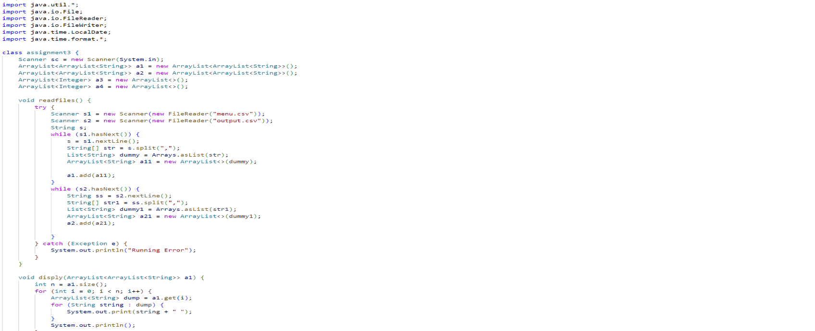

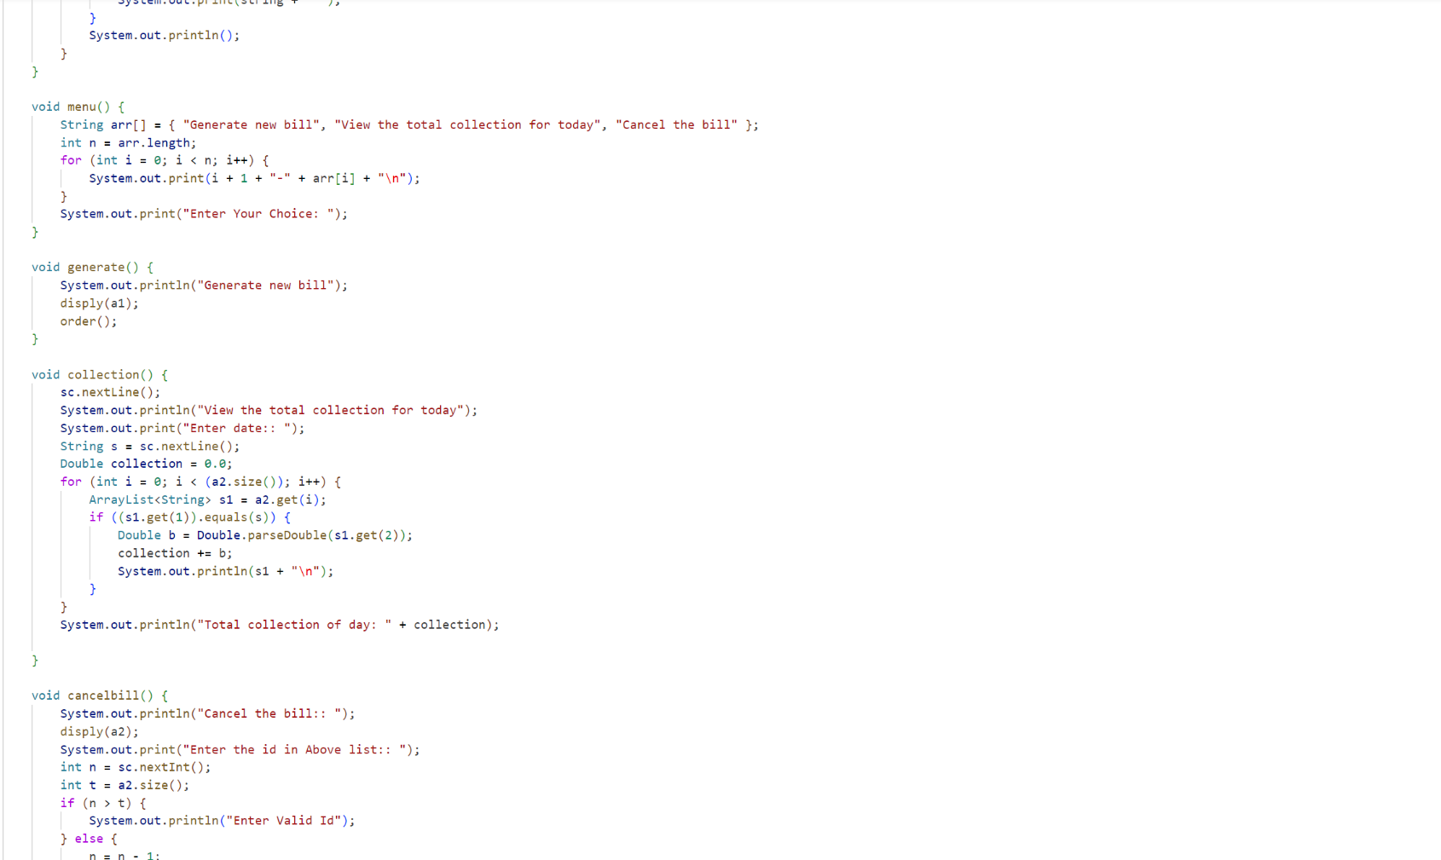

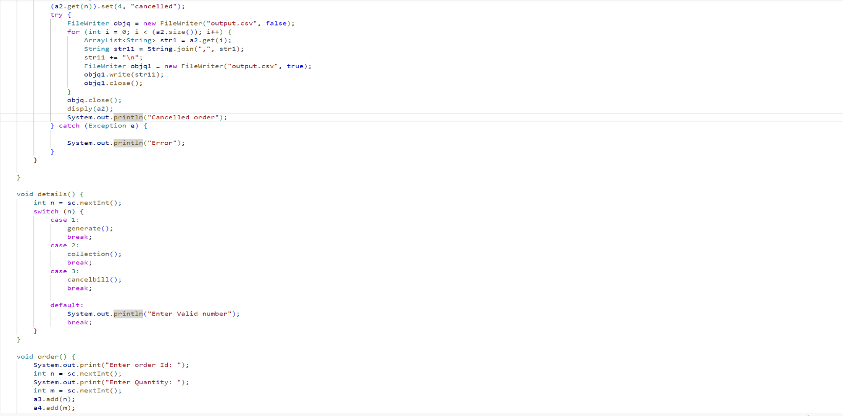

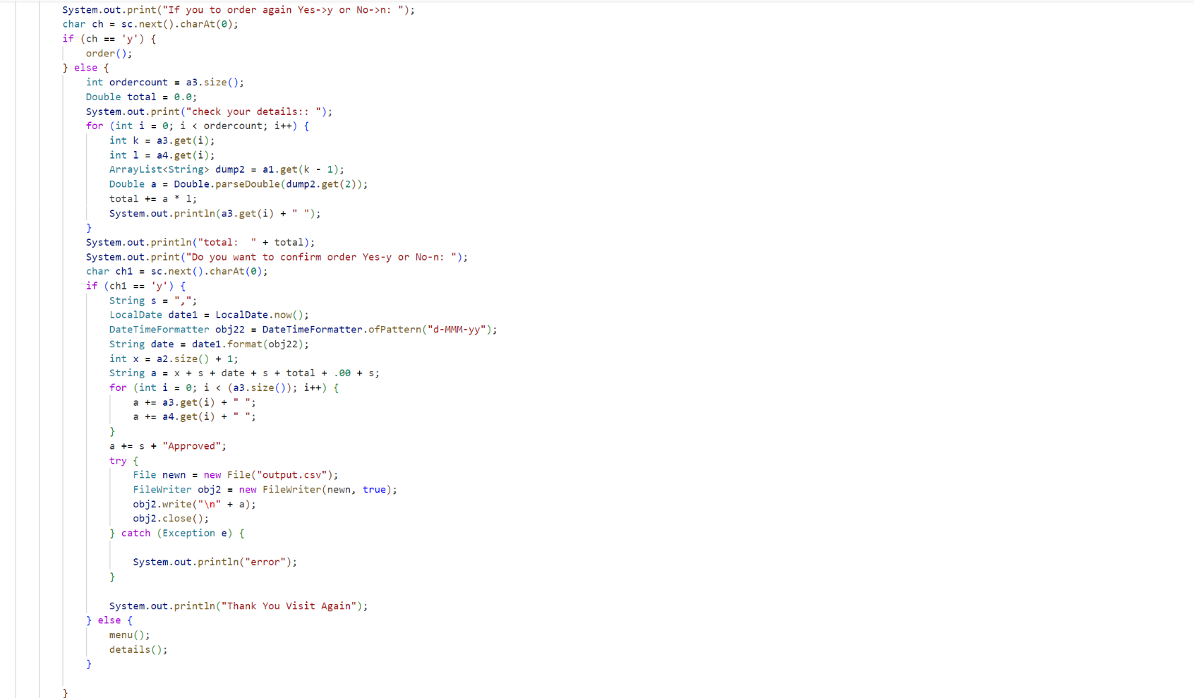

p

* **PROJECT OUTPUTS**

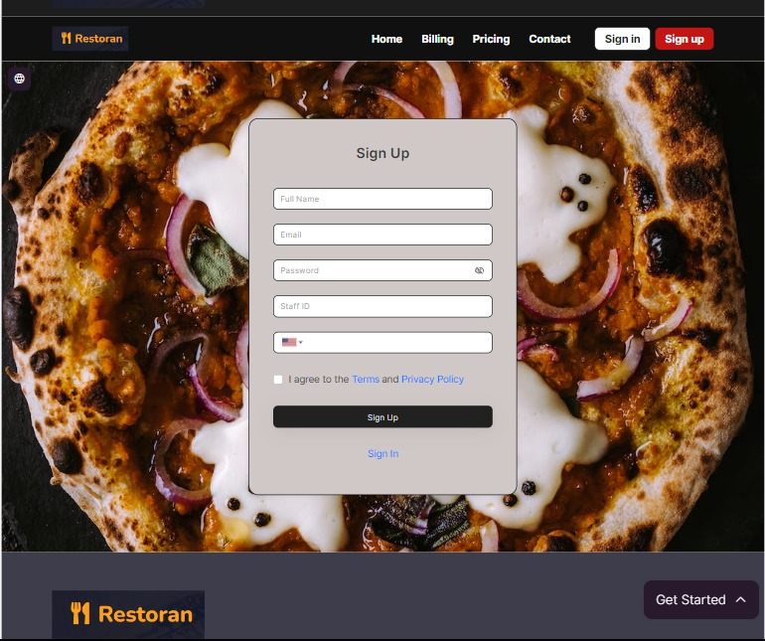

**Signup Page**

* This page is for a Swing-based GUI application that provides a login interface. It connects to a database, allows users to input a username and password, and checks these credentials against records in the database. If the credentials match, it displays a success message and opens a new window; otherwise, it shows an error message.

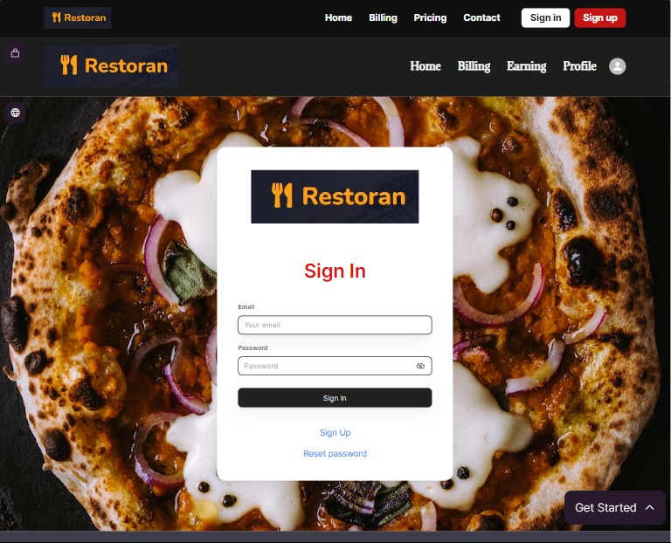

**Sign In**

* 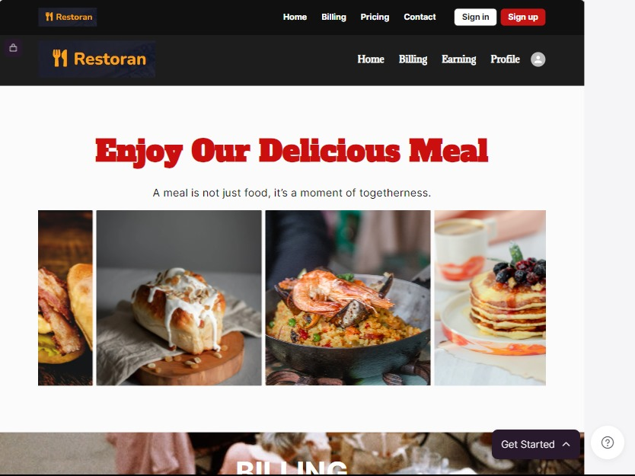After the successful login user can see the welcome message and his/her restaurant name on the top left side of the screen and on the right side there are various clickable options from where user can perform various tasks and also you can see "To do" form there you can add any information or activities you perform or want someone else to perform.
* Once the customers are done with their meal, they ask for the bill. All the items they have ordered are entered in the application according to the category of the food and it will automatically generate the total amount including tax and VAT. In this page once you provide all the necessary data then you will get following output

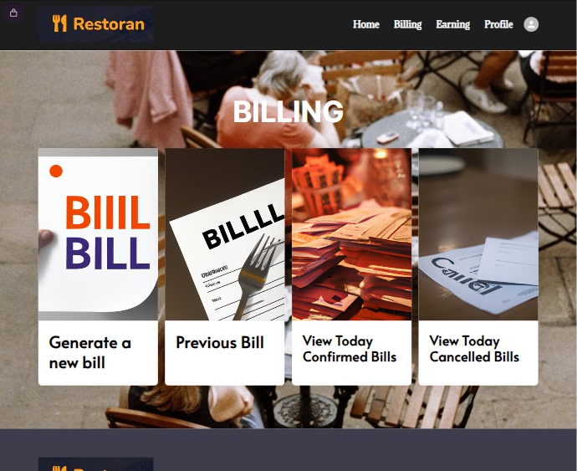

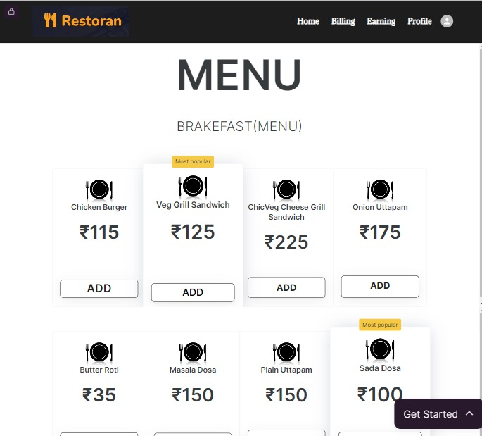

**Menu page**

* In this page user can add the reservation time as per the customer's wish. Here customers details like name, contact number and email are entered and also the number of guests they are coming with and the date and time then the reservation is made. The output of reservation page once all the details are added.

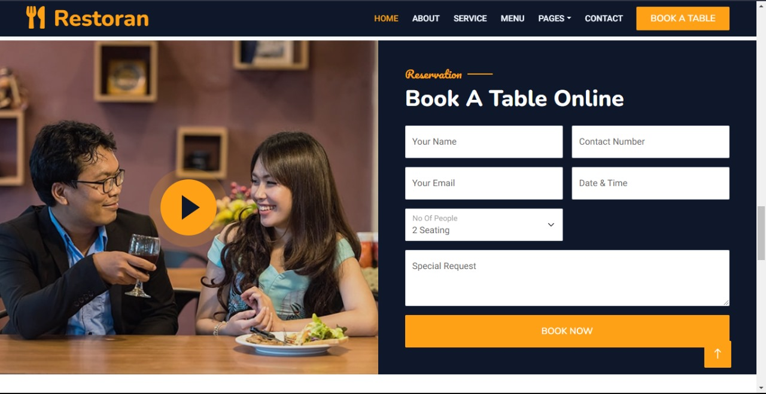

**Reservation Page**

* In this page admin can add, remove and edit the items in the menu. Here admin can add food category, food name and its price. Admin can add menu under the category by simply clicking on manage menu option in the tool bar. When add menu button is clicked under manage menu, following action takes place For instance category:

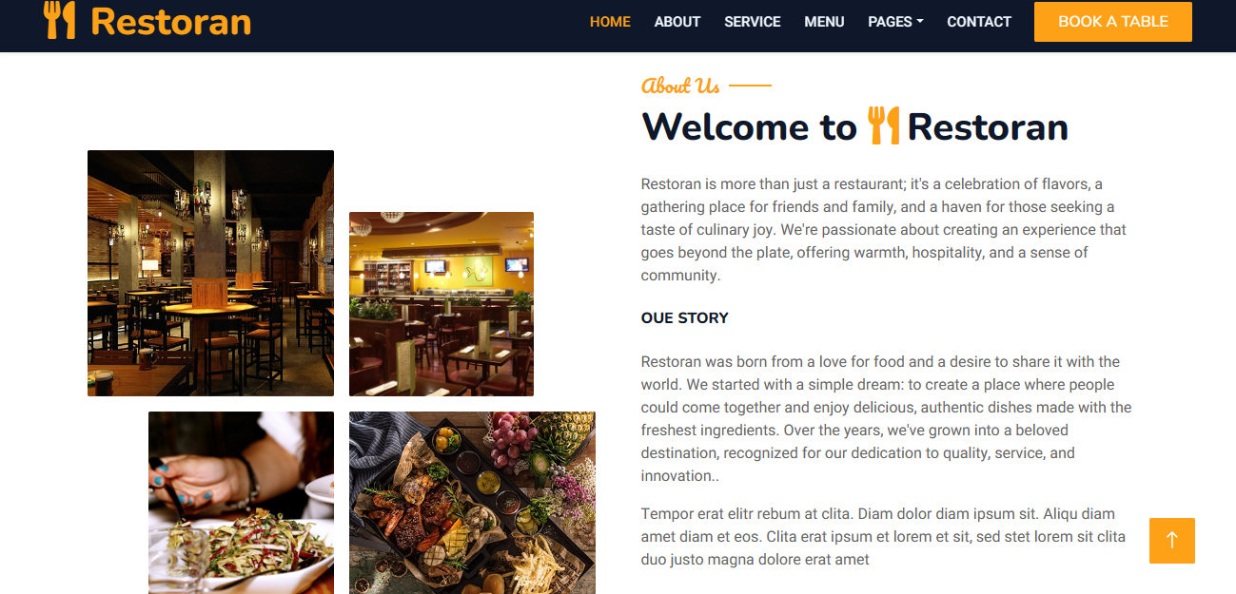

* The welcome page of customer website , where the customer can view the all the information of the restuenrt and other

**Menu Management Page**

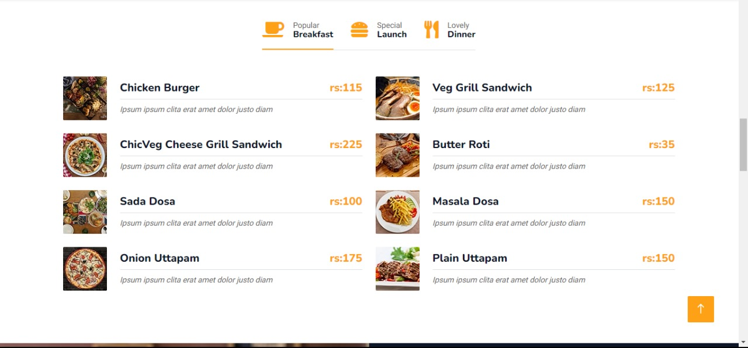

* Once the customers are done with their meal, they ask for the bill. All the items they have ordered are entered in the application according to the category of the food and it will automatically generate the total amount including tax and VAT. In this page once you provide all the necessary data then you will get following output

The team

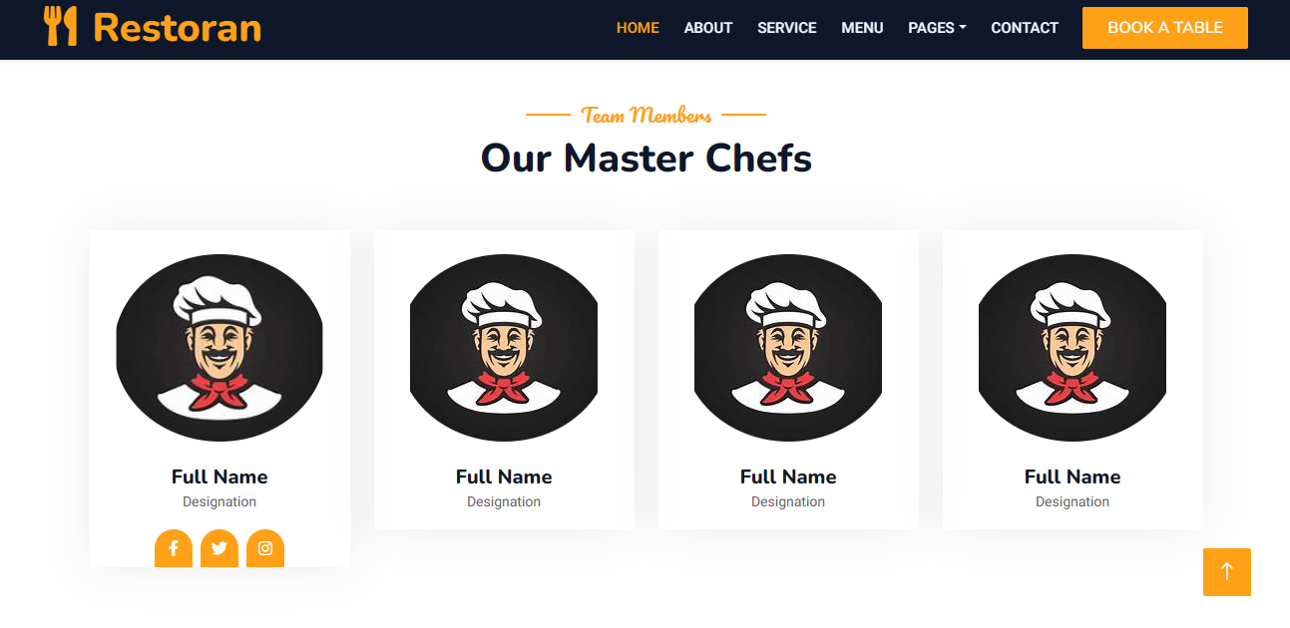

**The coustmer review**

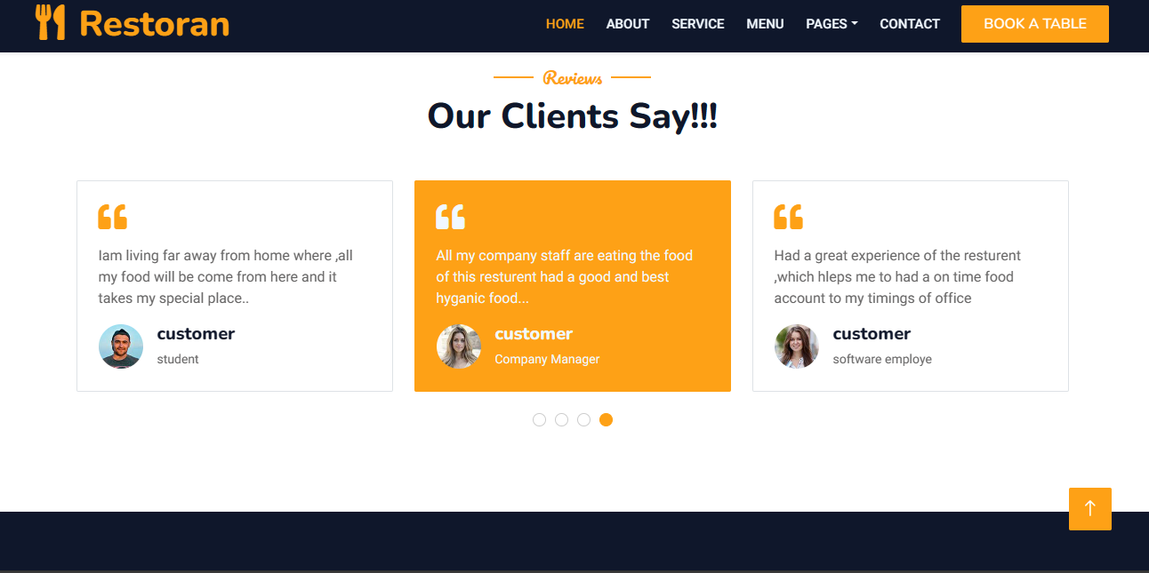

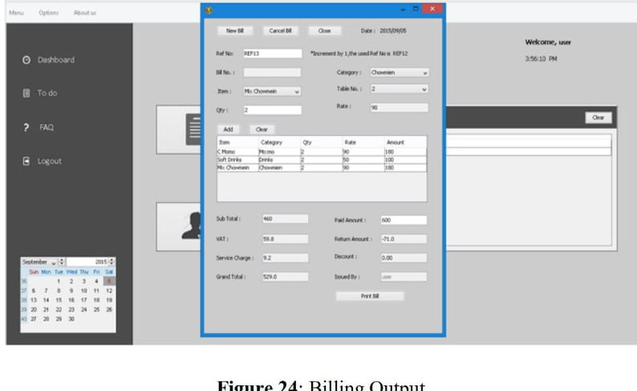

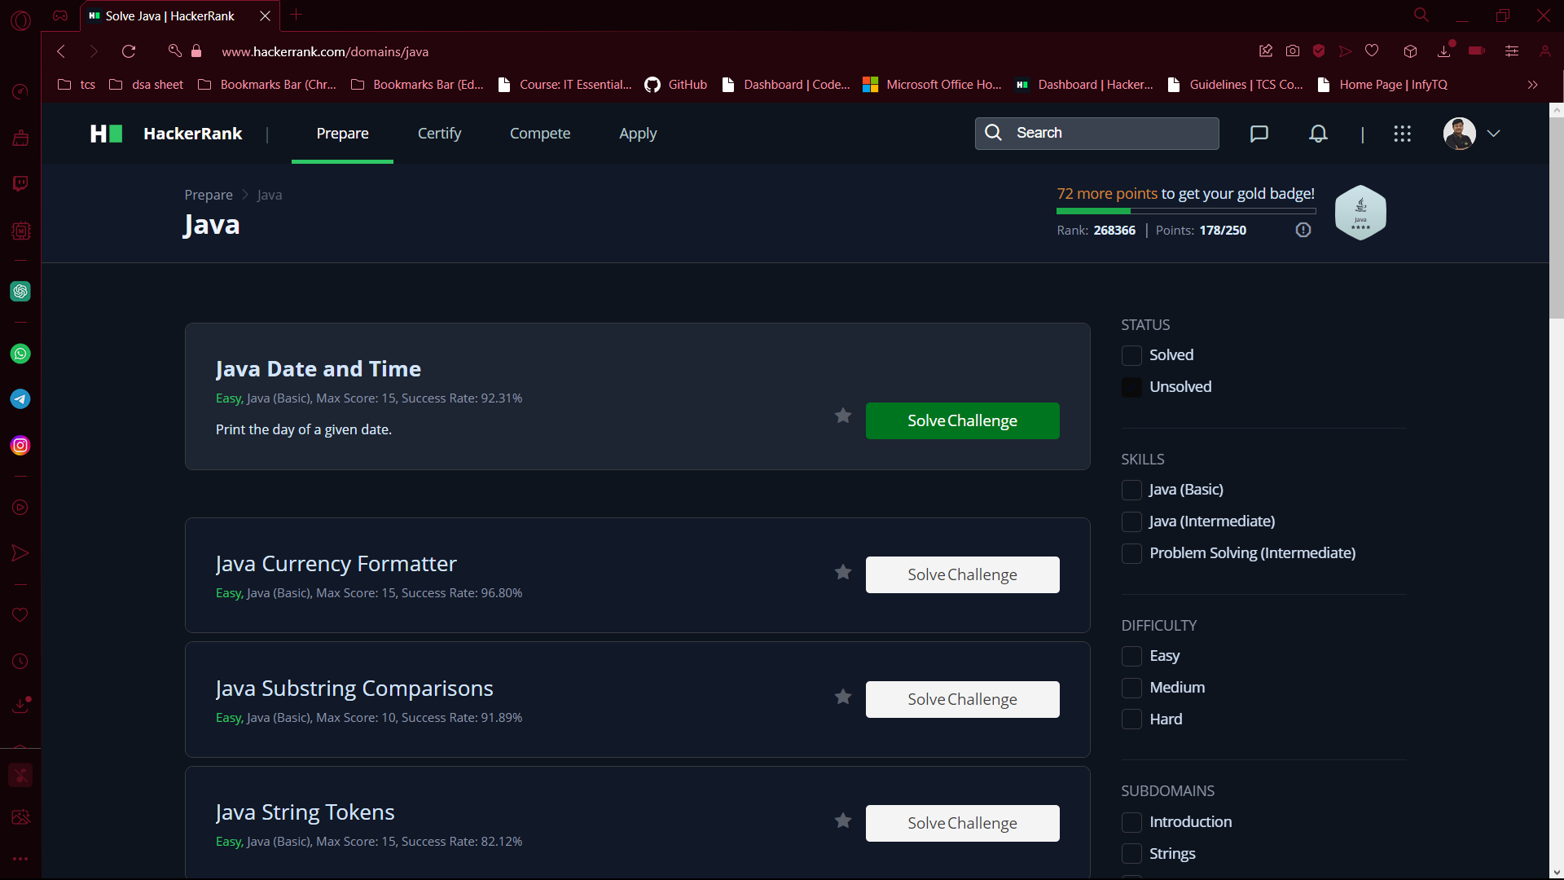

**Hacker Rank Java Link:**

[**https://www.hackerrank.com/domains/java?filters%5Bstatus%5D%5B%5D=unsolved&badge_type=java**](https://www.hackerrank.com/domains/java?filters%5Bstatus%5D%5B%5D=unsolved&badge_type=java)

* **Git Hub Link:**

[**SADHIKSK/Resturant-app: full code of resturant app code to describe the billing section of the app in present running resturants (github.com)**](https://github.com/SADHIKSK/Resturant-app)